PREMISES INFORMATION PLAN REVIEW & SOLUTON

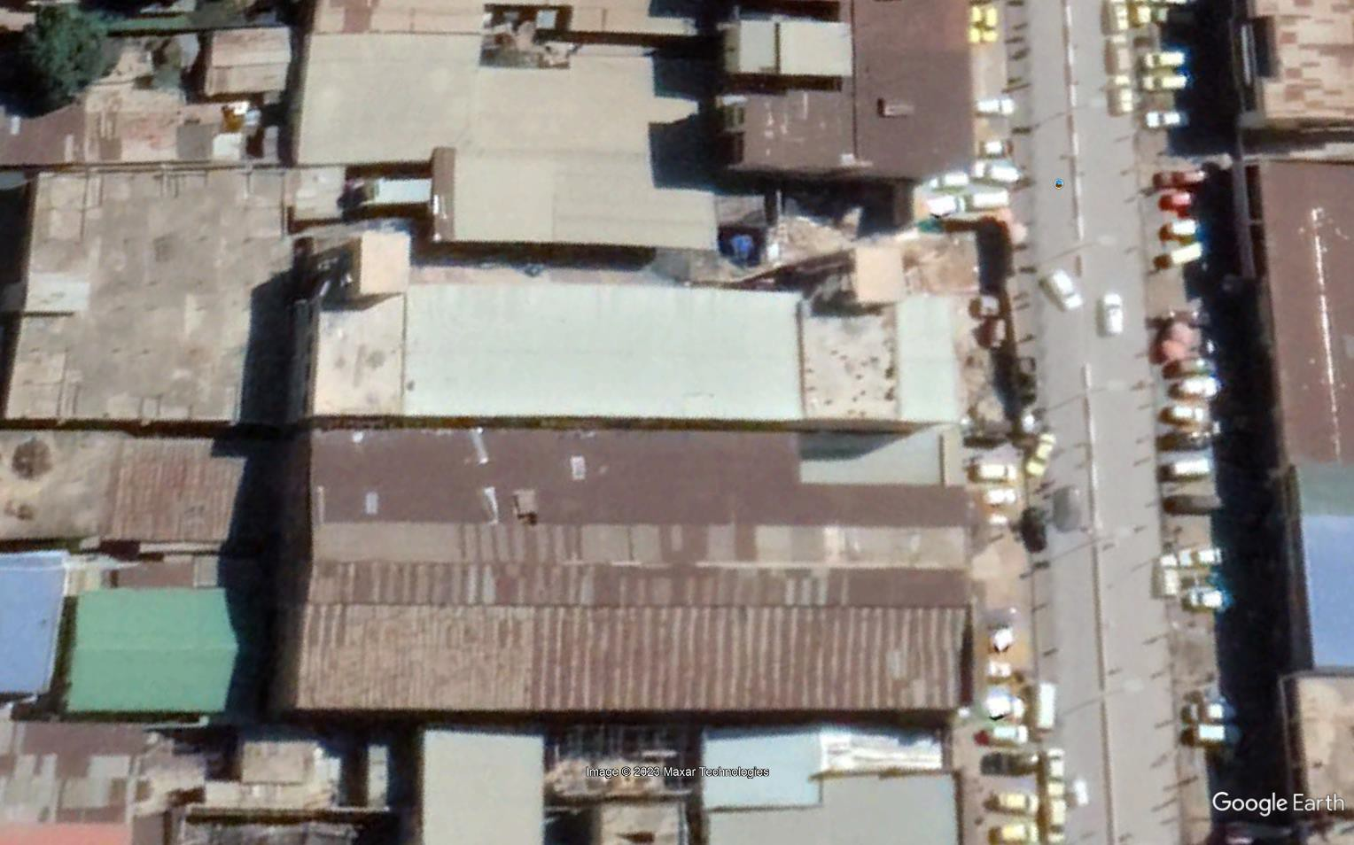

|  |  |
| --- | --- |
| **SITE NAME** | BELTEXCO |
| **LOCATION** | Sendwe, Route Don Bosco, Lubumbashi |
| **OCCUPANCY CLASS** | Ordinary hazard-Group 1, free standing pallets |
| **CONSTRUCTION TYPE** | Multi span warehouse buildings |
| **OCCUPANCY LOAD** | 10-20 People at any time |
| **FIREZONE** | Warehouse & Shop |
| **WAREHOUSE FLOOR AREA** | ≈700sqm |

# DESCRIPTION OF OCCUPANCES OR HAZARDS WITHIN BUILDING

The premises consists of both administration office block and 4 multi connected warehouse which are used to store free standing palletized plastic packaged products & cosmetics among other products with an estimated stacking height from 1m to 2.4m depending on type of product. Fire risk hazard classification for the goods is Class A & B of ordinary hazard with a high fire risk load. The warehouse has limited ventilation which helps to minimize spread of fire but smoke build has a high risk of fatality. The major goods in the warehouse are plastic which are highly flammable. In the event of a fire the consequence falls within the orange and red zones as per table below.

|  |  |  |  |  |  |  |
| --- | --- | --- | --- | --- | --- | --- |
| **RISK** | | **CONSEQUENCE** | | | | |
| **MATRIX** | | **Insignificant** | **Minor** | **Moderate** | **Major** | **Catastrophic** |
| **LIKELIHOOD** | | **1** | **2** | **3** | **4** | **5** |
| First Aid | Medical Treatment | Lost Time | Fatality | > 1 fatality |
| **Almost certain** | **5** | **5** | **10** | **15** | **20** | **25** |
| **Likely** | **4** | **4** | **8** | **12** | **16** | **20** |
| **Possible** | **3** | **3** | **6** | **9** | **12** | **15** |
| **Unlikely** | **2** | **2** | **4** | **6** | **8** | **10** |
| **Rare** | **1** | **1** | **2** | **3** | **4** | **5** |

# SITE ACCESS FOR EMERGENCIES

The premises has a means of escape through the paths within the warehouse with minimum obstructions and proper housekeeping should be maintained

# RESOURCES FOR FIRE FIGHTING AVAILABLE

* No Firefighting resources could be identified at the time of survey

# PROPOSED SOLUTION FOR WAREHOUSE PROTECTION

* Fire extinguishers
* Self-alarm smoke Detectors
* Automatic Fire extinguishers

Based on the classes of Fire, ABC Dry powder fire extinguishers are recommended.

Overhead 6kg automatic extinguishers with will protect an area up to 4.13sqms will be ideal for the classes of fire applicable with a 68ºC red bulb automatic sprinkler fitted as standard Fitted with pressure gauge for routine inspection.

|  |  |  |
| --- | --- | --- |
| **CODE** | **PRODUCT DESCRIPTION** | **QUANTITY/WAREHOUSE** |
| MS201909110004 | 6kg Automatic Powder Fire Extinguisher ABC Dry powder | 55 |

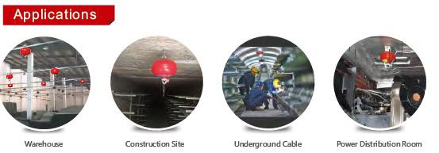

|  |  |  |
| --- | --- | --- |
| **CODE** | **PRODUCT DESCRIPTION** | **QUANTITY/WAREHOUSE** |
| MS201807160243 | 100kg ABC Dry powder fire extinguishers | 4 |
| MS201807160219 | 12kg ABC Dry powder Fire extinguishers | 6 |
| AFSFD01 | Self-Alarm smoke detectors | 36 |

**FIRE BEHAVIOR FROM IGNITION TO FLASHOVER (FIRE BLASTING AND BLOWING ALL OVER)**

